|  |  |  |  |
| --- | --- | --- | --- |
|  |  |  |  |
|  | Mémoire |  |  |
|  |  |  |
|  |  |  |

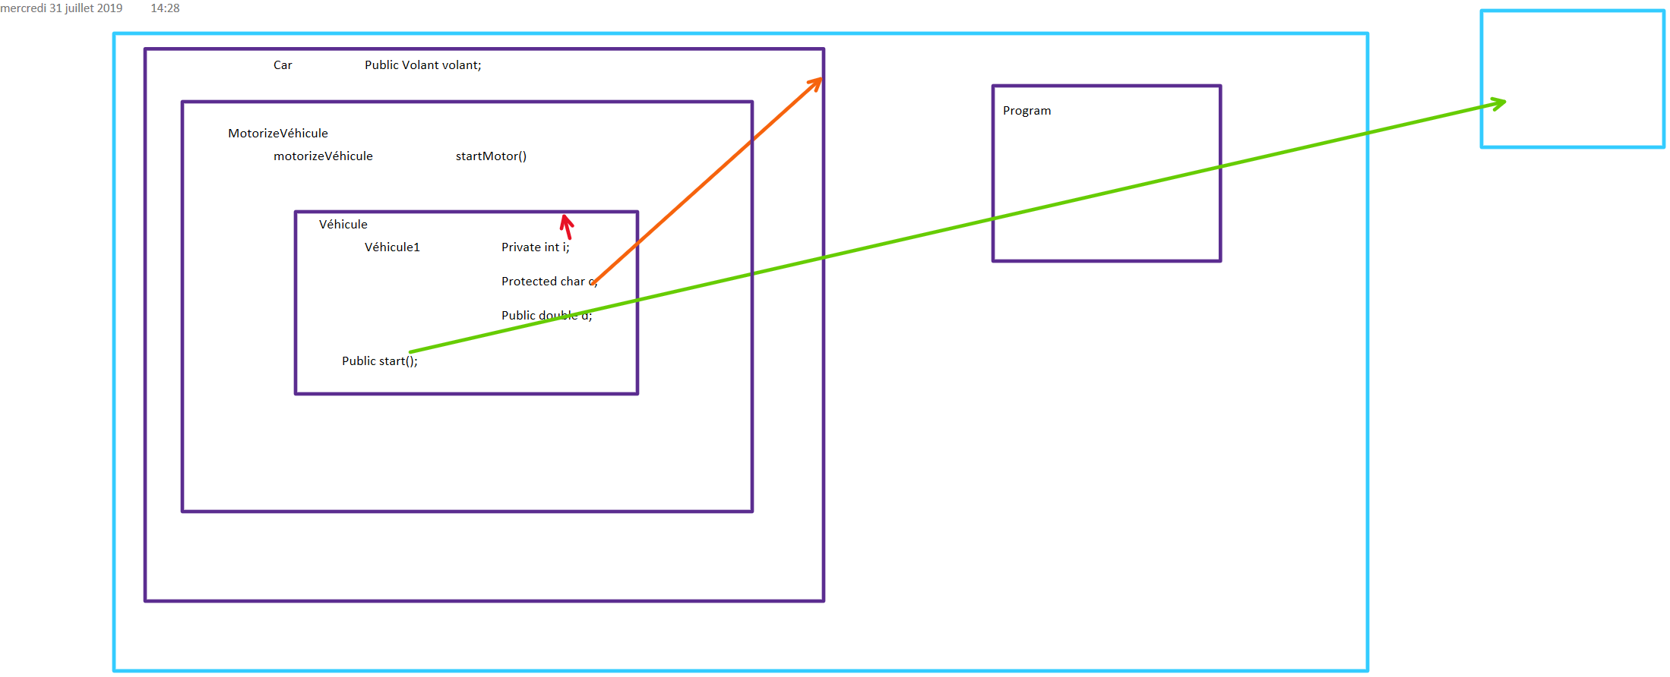

|  |  |  |  |
| --- | --- | --- | --- |
|  |  |  |  |
|  |  |  | Classes |
|  |  |  |
|  |  |  |

|  |  |  |  |
| --- | --- | --- | --- |
|  |  |  |  |
|  |  |  |  |
|  |  | Assemblies |
|  |  |  |